- Doplň do viet be verb + sloveso v ing-ovej forme. Použi sloveso v zátvorke.
kladné
I _______ (surf)____________________.
You_______(kayak)_____________________.
He________(sail)______________________.
We __________(snorkel)____________________.
They_________(waterski)_____________________.

záporné
I_________(dive)_____________________.
You __________(swim)______________________.
He____________(play)______________________.
We____________(windsurf)____________________.
They___________(run)______________________.

- Usporiadaj slová a napíš vety.
- They/TV/are/watching _____________________________________
- having/She/breakfast/is____________________________________
- playing/Sam/Is/the guitar/?__________________________________
- am /listening to/music/I_____________________________________
- isn´t/his/doing/He/homework________________________________
___________________________
- parents/My/aren´t/chess/playing_____________________________
_______________________________

- Čo robia? Napíš k obrázkom vety.
He__________________________________.
We ________________________________.
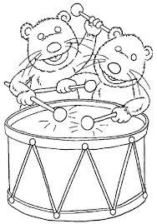They______________________________________.

- Prelož
clean______________ nákupné stredisko____________
friendly____________ nebezpečný_________________
ugly_______________ prázdniny___________________
look for ____________ potápať sa___________________
tall________________ padať ______________________

- K prídavnému menu napíš slovo s opačným významom
beautiful - ________________ dangerous - ______________
polluted - _________________ small - ________________

